- OVERVIEW OF HARDWARE COMPONENTS

- Draw a labeled diagram of a desktop PC, clearly marking the motherboard, CPU, RAM, GPU, and both HDD and SSD storage components.

- Introduction to a Desktop PC

- A Desktop PC (Personal Computer) is an electronic computing device designed for use at a fixed location, such as a home, office, school, or business. It consists of several hardware components that work together to process data, store information, and perform various tasks efficiently. Desktop PCs are widely used for education, office work, gaming, programming, graphic designing, video editing, and internet browsing. They are known for their high performance, easy upgradability, and long lifespan.

- Main Components of a Desktop PC

1. Motherboard
- The motherboard is the main circuit board of the computer.
- It connects all hardware components and allows them to communicate with each other.
- It contains the CPU socket, RAM slots, storage connectors, and expansion slots.
2. CPU (Central Processing Unit)
- The CPU is known as the brain of the computer.
- It processes instructions and performs calculations.
- It controls all operations carried out by the computer.
3. RAM (Random Access Memory)
- RAM is the computer's temporary memory.
- It stores data and programs currently in use.
- More RAM improves multitasking and overall system performance.
4. GPU (Graphics Processing Unit)
- The GPU processes graphics and visual data.
- It improves gaming, video editing, 3D rendering, and graphic design performance.
- It can be integrated into the CPU or installed as a dedicated graphics card.
5. HDD (Hard Disk Drive)
- The HDD is a permanent storage device.
- It provides large storage capacity at a lower cost.
- It stores the operating system, software, documents, videos, and other files.
6. SSD (Solid State Drive)
- The SSD is a high-speed storage device with no moving parts.
- It provides much faster boot times and application loading than an HDD.
- It is more durable, energy-efficient, and reliable.
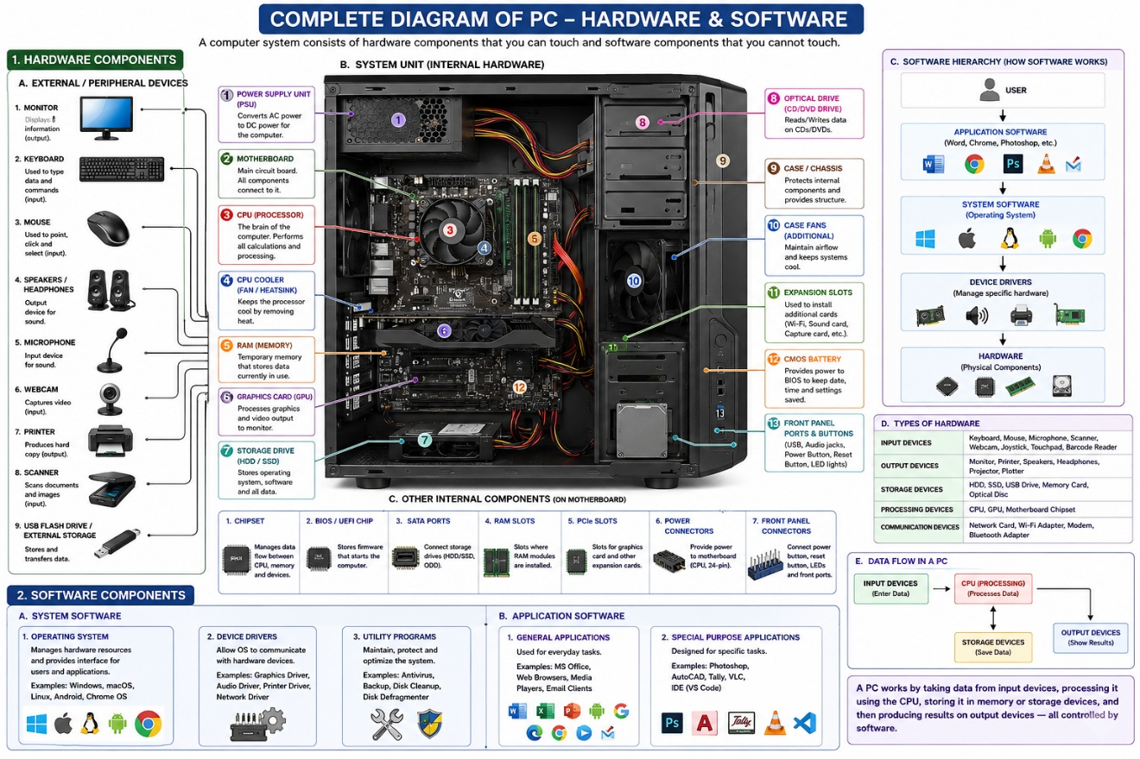

Create a comparison table showing the main differences between HDD and SSD storage in terms of speed, durability, and typical use cases.<br ><br><em><strong>Hint:</strong> Think about which one is faster, which is more shock-resistant, and where you would usually find each type (laptop, gaming PC, etc.).</em>
- Introduction

Storage devices are essential components of a computer because they store the operating system, software, and user data. The two most common types of storage devices are the Hard Disk Drive (HDD) and the Solid State Drive (SSD). Although both perform the same basic function of storing data, they differ significantly in terms of speed, durability, power consumption, cost, and typical use cases. Understanding these differences helps users choose the most suitable storage device based on their performance needs and budget.

Feature | HDD (Hard Disk Drive) | SSD (Solid State Drive)
Full Form | Hard Disk Drive | Solid State Drive
Storage Technology | Uses spinning magnetic disks (platters) and a mechanical read/write head. | Uses flash memory chips with no moving parts.
Speed | Slower data access and file transfer speeds. Typical speed: 80–160 MB/s. | Much faster data access and transfer speeds. Typical speed: 500 MB/s to over 7000 MB/s (NVMe SSDs).
Boot Time | Takes longer to start the operating system. | Boots the operating system much faster.
Application Loading | Programs and games load more slowly. | Applications and games load quickly.
Durability | Less durable because moving parts can be damaged by shocks or drops. | More durable and shock-resistant because there are no moving parts.
Noise | Produces noise due to spinning disks and moving heads. | Operates silently.
Power Consumption | Consumes more power. | Consumes less power, improving battery life in laptops.
Heat Generation | Generates more heat during operation. | Generates less heat.
Storage Capacity | Available in very large capacities at lower cost. | Available in large capacities but usually more expensive.
Cost per GB | Cheaper and more economical for large storage needs. | More expensive per GB of storage.
Weight | Heavier due to mechanical components. | Lighter and more compact.
Reliability | Can fail if subjected to physical shock or vibration. | More reliable for portable devices because of higher shock resistance.

- Summary
• SSD is faster than HDD and provides quicker boot times, faster file transfers, and better overall system performance.
• SSD is more durable because it has no moving parts, making it resistant to shocks and vibrations.
• HDD is cheaper and offers larger storage capacities at a lower cost.
• SSDs are commonly used in modern laptops, gaming PCs, and high-performance systems.
• HDDs are commonly used for backups, large media collections, and situations where maximum storage at a low cost is important.
- Conclusion
If speed and performance are the priority, an SSD is the better choice. If large storage capacity at a lower price is required, an HDD is a good option. Many modern computers use both: an SSD for the operating system and applications, and an HDD for storing large files.

3. Write a short explanation (2-3 sentences each) describing the role of the CPU, RAM, and GPU in running a game like PUBG or Free Fire on a PC.

CPU (Central Processing Unit)
The CPU is the main processor of the computer that executes game instructions and performs calculations. In games like PUBG or Free Fire, it handles player actions, game logic, enemy movements, and communication between different hardware components.

RAM (Random Access Memory)
RAM temporarily stores the data and resources that the game needs while running. It allows the CPU to quickly access game files, maps, textures, and player information, helping the game run smoothly without frequent loading delays.

GPU (Graphics Processing Unit)
The GPU is responsible for rendering images, animations, and visual effects on the screen. In games like PUBG or Free Fire, it processes 3D graphics, lighting, shadows, and textures to provide smooth gameplay and high-quality visuals.
4.Imagine you want to upgrade your PC to run the latest version of FIFA smoothly. List which hardware components you would consider upgrading and explain why for each.
Component | Why Upgrade?
CPU (Central Processing Unit) | The CPU processes game instructions, player movements, and game logic. Upgrading to a faster and more powerful CPU helps improve overall game performance and reduces lag during matches.
RAM (Random Access Memory) | RAM stores the game data that is currently in use. Increasing RAM (for example, from 8 GB to 16 GB) allows the game to load assets more quickly and helps prevent stuttering when multitasking.
GPU (Graphics Processing Unit) | The GPU is responsible for rendering graphics, animations, and visual effects. Upgrading the GPU provides higher frame rates, smoother gameplay, and better image quality, especially at high resolutions and graphics settings.
SSD (Solid State Drive) | Installing FIFA on an SSD significantly reduces loading times compared to an HDD. The game starts faster, matches load more quickly, and overall system responsiveness improves.
Power Supply Unit (PSU) | If a new CPU or GPU requires more power, the power supply may also need an upgrade. A reliable PSU ensures stable performance and protects the system from power-related issues.
Cooling System | More powerful hardware generates additional heat. Upgrading the CPU cooler or adding extra case fans helps maintain safe temperatures and prevents performance loss due to overheating.
Conclusion
For the best FIFA gaming experience, the most important upgrades are the GPU, CPU, RAM, and SSD. These components directly affect game speed, graphics quality, loading times, and overall smoothness during gameplay.
• GPU: Upgrade for better graphics quality and higher frame rates.
• RAM: Increase RAM to improve loading times and smooth gameplay.
• SSD: Install FIFA on an SSD for faster boot and loading speeds.
• CPU: Upgrade if the processor struggles with modern game requirements.

Final Conclusion
This assignment helped me understand the major hardware components of a computer system and their functions. I learned the differences between HDDs and SSDs, the roles of the CPU, RAM, and GPU in gaming, and the hardware upgrades needed for better gaming performance. Understanding these components is important for building, maintaining, and improving computer systems.

